CURRICULAM VITAE
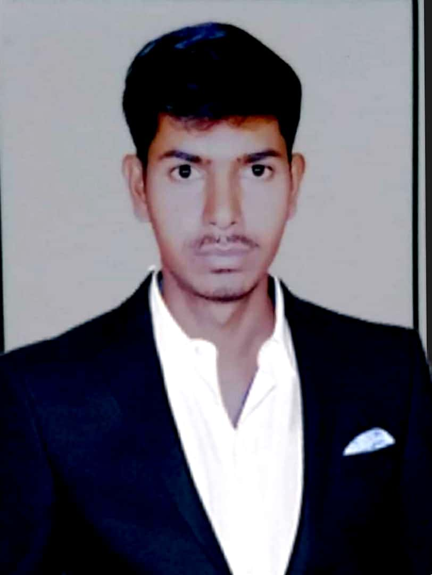

Abdul Aziz
E-mail: Abdul_aziz898@yahoo.com
M: - +91-767 686 4454

Professional Profile:
B.E in Electrical and Electronics with 4+ Year experience in Installation and Commissioning of Solar Plant and Sub Station Maintenance. I have Knowledge in Power Transformer, Switchgear and Transmission line.

Work Experience:

Project Engineer
Aarvi Encon Pvt Ltd (Client: Bosch Limited) Feb-2018 to Present

- Installations & commissioning of Module, DC Connection in MW Power Plant
- Support & Coordinate with Logistic & Commercial for smooth execution of project.
- Preparation of time oriented efficient project plan for solar system project development, monitoring, and evaluation activities
- Understand electrical single-line diagrams, panel schedules or connection diagrams for solar electric systems using computer-aided design (AutoCAD) software.
- Provide technical direction or support to installation teams during installation, start-up, testing, system commissioning or performance monitoring
- Design Consideration for Installation method.
- Ensure safe erection, installation, testing, commission of the Solar PV Plant.
- Coordinate with Contractor for smooth execution of Project.
- Transmission Line work.
- Material management at site controlling & Maintenance of Inventory at site
- Attend technical meetings/seminars with Client/Contractors/Consultants.
- Hand Over site to Customer.

Site Engineer
Solarig Gensol utility Pvt Ltd April-2017 to Feb-2018

- Transformer, Inverter, LT panel & HT Panel Installation & Commissioning.
- SCADA Monitoring and Analysis of different KW-MW scale Solar power projects.
- Preparation of Detailed Daily report for KW-MW scale projects.
- Plant Performance Analysis.
- Maintenance of inverters, strings and modules when needed.
- Maintaining Equipment history.
- Coordinating between Commissioning activities and Client, ensuring all strategies accordance to their need.
- Preparation of Schedules for regular Maintenance of inverters, Transformers, HT,LT panels and 33KV Switchyard equipment

Electrical Engineer
Tirumala Electrical and Enterprises. June-2015 to March-2017

Nature of Work: 110/33/11KV Sub Station Maintenance

- Operation and Maintenance of substation equipments including issuing safety work permits, troubleshooting, condition monitoring etc.
- Maintenance of power transformers (110/33 KV & 33/11 KV), Circuit breakers (SF6, Vacuum), CTs, PTs, LA, Battery, Battery Chargers etc.
- Operation and Maintenance of control and Relay panels, LV panel, DB etc.
- Maintaining various records such as daily, monthly operating reviews, daily log sheets, different registers etc.
- Supervising all ongoing works at yard and line.
- Liaising with other department.
- Trouble shooting.

Technical skills:

- Auto CAD version 2018.
- Electrical Design ( Commercial buildings)
- Dialux Software – Lighting Calculations.
- MS Office

Education details:

Name of the course | Board/University | School/College | Year of passing
B.E (EEE) | VTU | Guru Nanak Dev  Engineering College,  BIDAR | 2015
12th (PCMB) | Pre University  College, Karnataka Board | Sri Dattagiri Maharaj Composite Junior College, Bidar | 2011
10th | SSLC, Karnataka  Board | Karnataka High School Bidar | 2009
Passport Details:

Passport No : N0879332
Date of issue : 07/07/2015
Date of expiry : 06/07/2025
Place of issue : Bangalore

Personal Details:

Father’s Name : SHAIK ZAINUDDIN

Date of Birth : 1994

Sex : Male

Nationality : Indian

Marital Status : Single

Languages Known : English, Hindi, and Kannada.

Permanent Address : #.12-01-491, BEHIND
KARANATAKA COLLEGE,
JERUSALEM COLONY,
BIDAR-585401.
Declaration:
I hereby declare that all the above information furnished by me are true and correct to the best of my knowledge.

Date: Yours truly,
Place: [Abdul Aziz]

